**Housing Prices in Metropolitan Areas of India**

House price prediction in a metropolitan city in India is a valuable solution for potential home buyers, real estate agents, and investors. By leveraging historical sales data, property details, and location-specific information, a predictive model can accurately estimate house prices. The model's scalability, real-time updates, user-friendly interface, and transparency ensure it meets the needs of stakeholders. Integration capability, data privacy, and cost-effectiveness are also important considerations. By addressing these requirements, the prediction model provides reliable insights, empowering stakeholders to make informed decisions in the fast-paced real estate market.

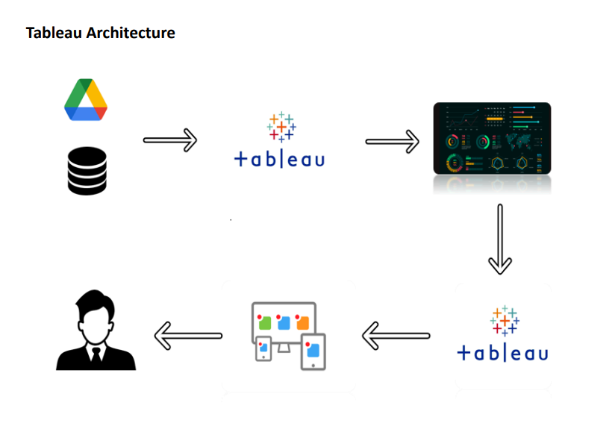

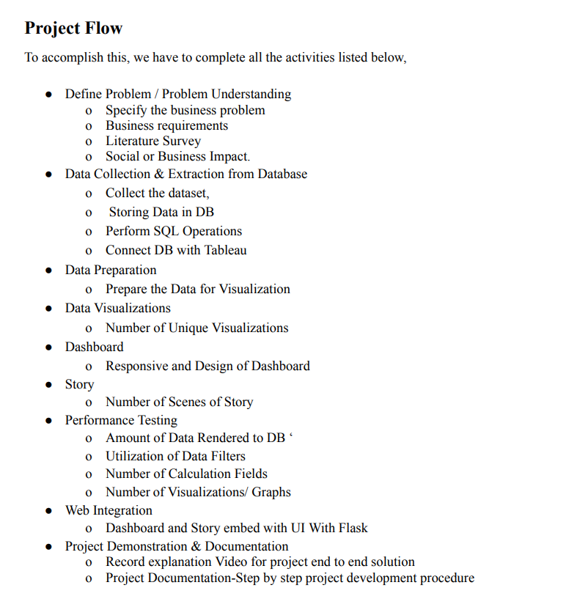

**Data Collection & Extraction from Database**

Data collection is the process of gathering and measuring information on variables of interest, in an established systematic fashion that enables one to answer stated research questions, test hypotheses, evaluate outcomes and generate insights from the data. Activity 1: Downloading the dataset Please use the link to download the dataset:

[Housing Prices in Metropolitan Areas of India (kaggle.com)](https://www.kaggle.com/datasets/ruchi798/housing-prices-in-metropolitan-areas-of-india)

Then creating dashboard

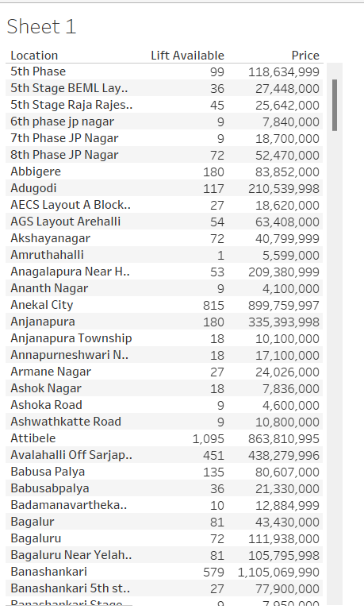

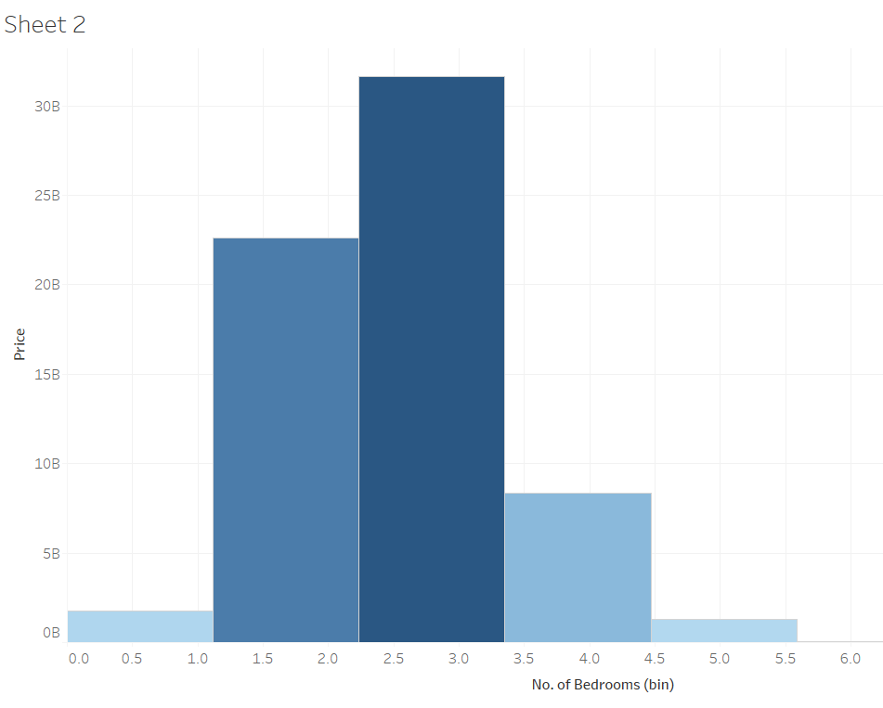

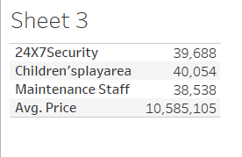

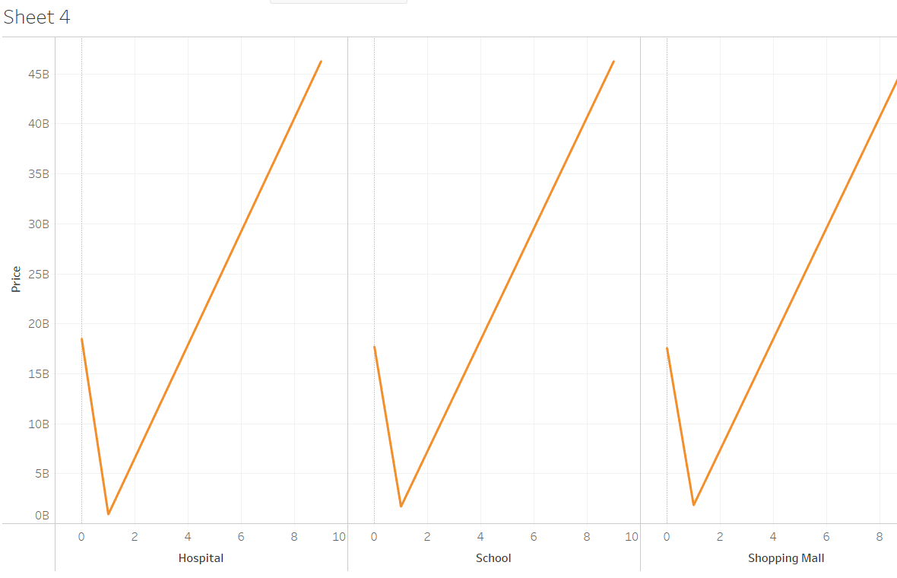

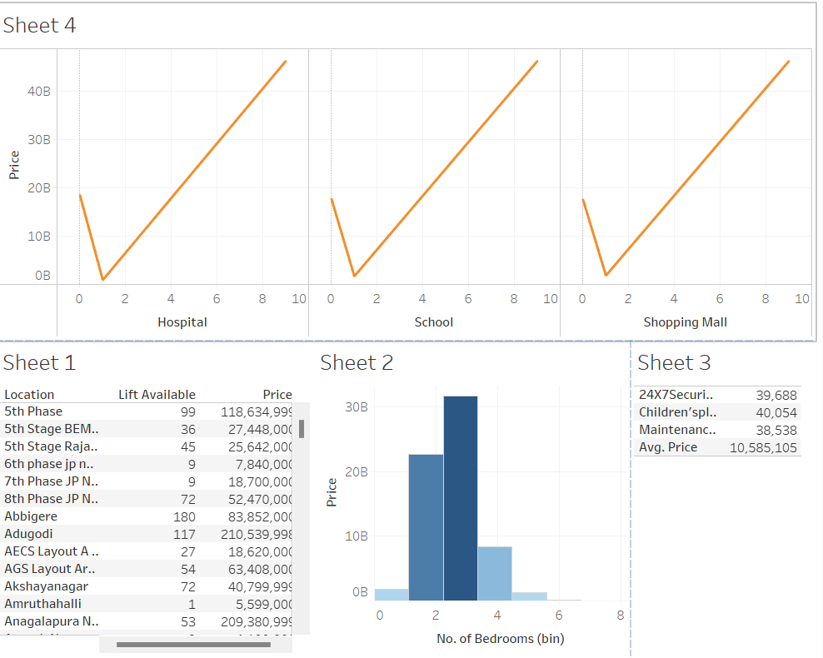

**Web integration**

Publishing helps us to track and monitor key performance metrics and to communicate results and progress. help a publisher stay informed, make better decisions, and communicate their performance to others. Publishing dashboard and reports to tableau public

Step 1: Go to Dashboard/story, click on the share button on the top ribbon

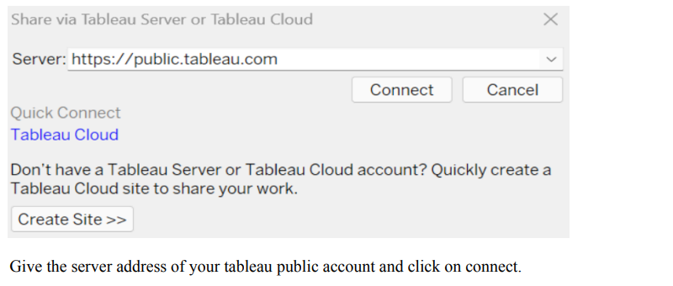

Step 2: Once you click on connect it will ask you for the tableau public username and password

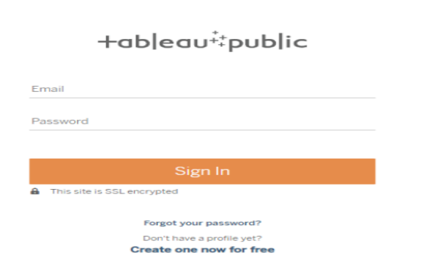

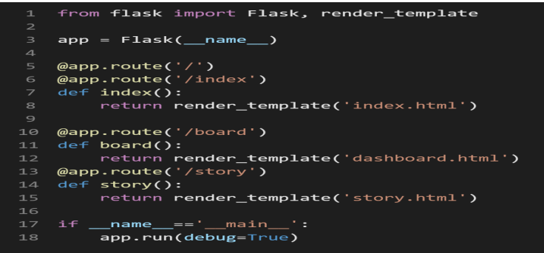

Once you login into your tableau public using the credentials, the particular visualization will be published into the tableau public Note: While publishing the visualization to the public, the respective sheet will get published when you click on the share option.

